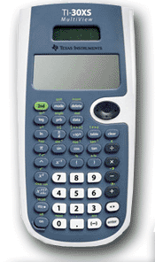
Algebra 1 Supplies
- 3 ring binder with dividers
- Pencils, Pens, Erasers
- College ruled paper
- Recommended: TI-30XS Calculator

